**CENWP-OD-B 13 July 2023**

**MEMORANDUM FOR THE RECORD**

**SUBJECT: 23BON056 MFR AFF Valve 15 PL Morts and Chinook Mort**

On the morning of 13 July, Columbia River Inter-Tribal Fish Commission (CRITFC) Biologists notified Bonneville Project Biologists of two Pacific Lamprey mortalities and one smolt Chinook salmon found on the Valve 15 trash rack in the Adult Fish Facility (AFF). The fish were scanned for PIT tags, inspected, and returned to the river.

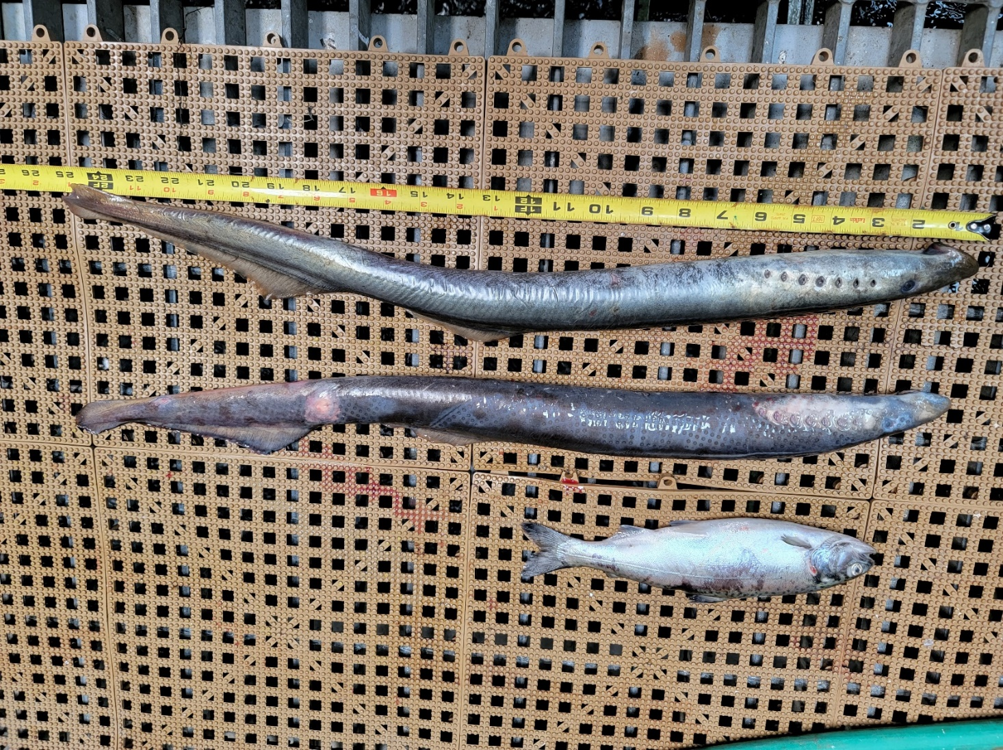#1 - lamprey

1. Species – Pacific Lamprey (*Entosphenus tridentatus)*
2. Origin – Unknown
3. Length – In descending order: 63.5 cm, 64.6 cm
4. Marks and tags – None
5. Marks and Injuries found on carcass – None
6. Cause and Time of Death – Unknown
7. Future and Preventative Measures – None

#2 - Chinook

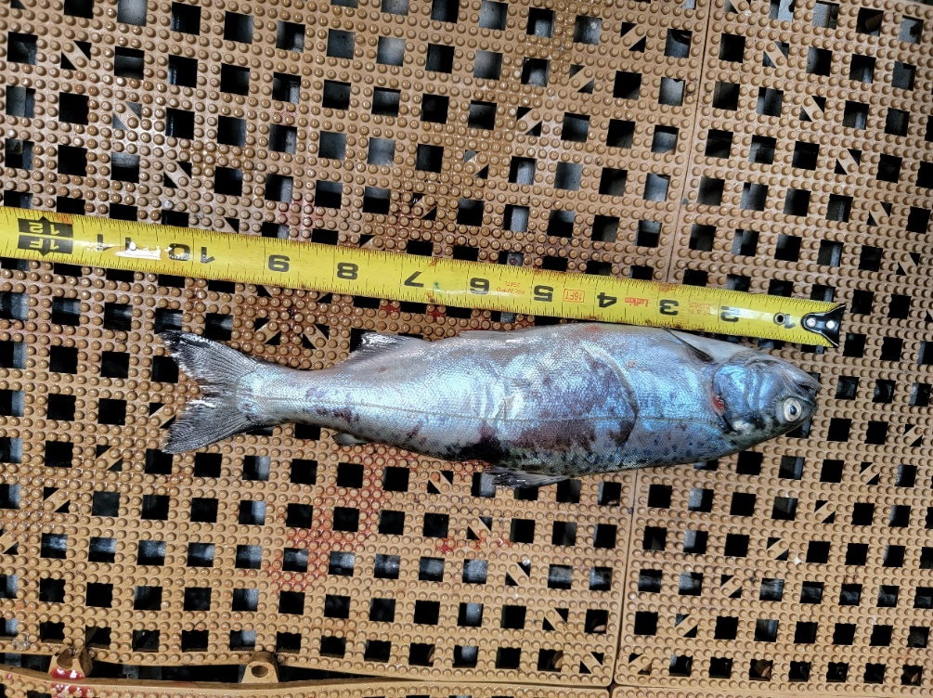 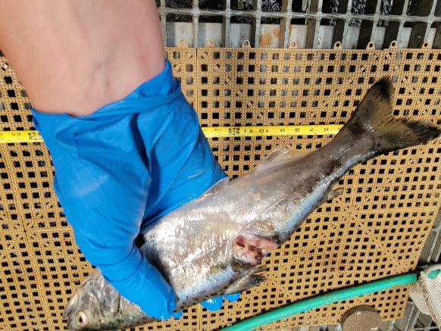

1. Species – Chinook Salmon (*Oncorhynchus tshawytscha)*
2. Origin – Unknown
3. Length – 26.9 cm
4. Marks and tags – None
5. Marks and Injuries found on carcass – Large dorsal laceration, possible predation wound (see photo above)
6. Cause and Time of Death – Possibly avian predation
7. Future and Preventative Measures – None

Sincerely,

Bonneville Project Fisheries